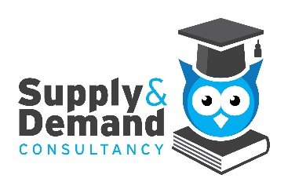

Supply & Demand Consultancy Ltd

Disciplinary and Dismissal Policy

Reviewed: September 2025
Next Review: September 2026

Purpose
The purpose of this policy is to set out a fair, transparent, and consistent approach for dealing with disciplinary issues that may arise with teaching staff engaged by Supply & Demand Consultancy Ltd. The aim is to encourage improvement in behaviour and performance and outlines steps for managing these issues in compliance with UK legal standards.
Scope
This policy applies to all contract for services teaching staff engaged by Supply & Demand Consultancy Ltd.
Principles
- All disciplinary matters will be handled fairly, consistently, and without discrimination.
- Individuals will be informed of the allegations against them and given the opportunity to respond before any decision is made.
- No disciplinary action will be taken until a full investigation has been completed.
- The level of disciplinary action will depend on the seriousness of the offence.
- Timely resolution to minimise disruption

Informal Resolution
Minor issues should normally be resolved informally through discussion, guidance, or additional training.
If informal action fails to resolve the issue or the matter is more serious, the formal disciplinary procedure will be used.

Disciplinary Procedure

Disciplinary Investigation
- An investigating officer will be initiated when serious breaches are reported, who will gather facts and evidence.
- The individual will be informed of the allegations and be asked to respond. The individual may be asked to attend an investigatory meeting.
Disciplinary Meeting
- If required, the individual will receive written notice of the allegations, supporting evidence, and the date of the meeting.
- The individual will have the right to state their case and present evidence or witnesses.

Decision and Outcome
Possible outcomes include:
- No action
- Verbal (informal) warning
- Suspension of assignment
- Termination (depending on the severity of the misconduct)
The Individual will be informed of the decision in writing, including the reasons and their right of appeal.

Gross Misconduct
Examples include:
- Theft, fraud, or dishonesty
- Violence or threats of violence
- Serious bullying or harassment
- Breach of confidentiality
- Unethical behaviour
- Being under the influence of drugs or alcohol at work
- Actions that bring harm to the business or its clients
Each case will be considered individually.

Appeals
Individuals have the right to appeal any disciplinary decision.
- Appeals must be submitted in writing within 14 days of receiving the decision letter, outlining their grounds for appeal.
- The appeals process will be handled fairly, consistently, and without discrimination.

Record Keeping
All disciplinary records will be kept confidentially and in accordance with UK GDPR
Related Policies
This policy should be read alongside
- Equality, Diversity and Inclusion Policy
- Code of Conduct

Review
This policy will be reviewed annually to ensure it remains compliant with current laws and best practice, with amendments where necessary.
Contact
info@supply-demand.co.uk
Tel: 020 8466 7946
Office 5 Willow Walk Business Centre, Willow Walk, Orpington BR6 7AA

